**Homework 14**

**Casey Sorrells**

Here is the UML-like diagram for the Concentration class:

|  |
| --- |
| Concentration |
|  |
| Concentration(Sprite sprites[]) void ifMouseIsClickedOnCardThenFlipCardFaceUp() int numberOfFaceUpCards() boolean doAllFaceUpCardsMatch() void flipAllCardsFaceDown() void makeAllFaceUpCardsInvisible() void resetAllCards() int numberOfFaceDownCards() int numberOfVisibleCards() void paintComponent(Graphics g) |

   
1) If you type this code into Game.java:  
  
String s = "hello";  
public void paintFrame(Graphics g) {  
    g.drawString(s,100,100);  
}

a) How often is the line      String s = "hello"      executed?

**Once**  
b) How often is the line      g.drawString(s,100,100)     executed?

**Every 15th of a second until the program is closed.**

2) Suppose I type this code into Game.java:  
  
int timeDelay = 30;  
public void paintFrame(Graphics g) {  
    timeDelay--;  
}

a) What is the value of timeDelay when the program launches?

**timeDelay is 30.**  
b) What is the approximate value of timeDelay after one second?

**timeDelay is 15.**  
c) What is the approximate value of timeDelay after two seconds?

**timeDelay is 0.**  
d) What is the approximate value of timeDelay after three seconds?

**timeDelay is -15.**  
e) What is the approximate value of timeDelay after four seconds?

**timeDelay is -30.**

3) Modify the code in question 2 so that timeDelay is decremented only if timeDelay is greater than 0.

**int timeDelay = 30;**

**public void paintFrame(Graphics g) {**

**if (timeDelay > 0) {**

**timeDelay--;**

**}**

**}**  
  
4) Suppose I type this code into Game.java:  
  
public void paintFrame(Graphics g) {  
    g.drawString("1",10,100);  
    g.drawString("2",10,120);  
    g.drawString("3",10,140);  
    if (true) return;  
    g.drawString("4",10,160);  
    g.drawString("5",10,180);  
    g.drawString("6",10,200);  
}

If I run Game.java, what will I see on the screen?

**1**

**2**

**3**

5) Take a look at this code:

|  |
| --- |
| /* Type your variable declarations here * int timeDelay;  public void initializeSprites(){     //type your sprite initialization code here     timeDelay = 15; }   public void paintFrame(Graphics g) {     /* Type your code here */      System.out.println("hello");     if (timeDelay>0) {         timeDelay--;         return;     }     System.out.println("goodbye");     timeDelay=15; } |

How often is "hello" written to the Console?

**14 times per/second**  
How often is "goodbye" written to the Console?

**1 time per/second, it will be the 15th word printed, like so:**

**hello**

**hello**

**hello**

**hello**

**hello**

**hello**

**hello**

**hello**

**hello**

**hello**

**hello**

**hello**

**hello**

**hello**

**goodbye**  
  
6) Write the code to create a stop watch.  Use g.drawString() to display the stop watch's time on the screen.

HINTS:  
    At the beginning of the game, set the watch’s time to 0    
    During the running of the game  
       draw the watch's time  
      delay the Game for one second  
      increment the stop watch’s time by 1

**Here is my code:**

**int timeDelay;**

**int counter = 0;  
  
public void initializeSprites(){  
    //type your sprite initialization code here  
    timeDelay = 15;  
}  
  
 public void paintFrame(Graphics g) {  
    /* Type your code here */   
    g.drawString(counter);**

**if (timeDelay>0) {  
        timeDelay--;  
        return;  
    }  
    counter += 1;  
    timeDelay=15;  
}**

7) Write the code to make a cat appear for 1 second, disappear for 1 second, appear for 1 second, disappear for 1 second, etc.    
HINTS:  
    At the beginning of the game, make the cat visible  
    During the running of the game  
        draw the cat  
        delay the game for one second   
        if he cat is visible then make the cat invisible or vice versa

**Here is my code:**

**int timeDelay = 15;**

**boolean visibleToggle = true;**

**Sprite cat1 = new Sprite(new ImageIcon("cat.gif").getImage(), 200, 100);**

public void initializeSprites(){

/* sprite initialization code goes here */

}

public void paintFrame(Graphics g) {

**if (timeDelay>0) {**

**timeDelay--;**

**if(visibleToggle) {**

**cat1.paintComponent(g);**

**}**

**return;**

**}**

**timeDelay=15;**

**if(visibleToggle) {**

**visibleToggle = false;**

**} else {**

**visibleToggle = true;**

**}**

}

Please use this UML-like diagram for the next few quesstions:

|  |
| --- |
| Concentration |
|  |
| Concentration(Sprite sprites[]) void ifMouseIsClickedOnCardThenFlipCardFaceUp() int numberOfFaceUpCards() boolean doAllFaceUpCardsMatch() void flipAllCardsFaceDown() void makeAllFaceUpCardsInvisible() void resetAllCards() void paintComponent(Graphics g) |

8) What is the name of this class?

**Concentration.**

9) What are the names of the properties that are in this class?

**Concentration has no properties.**

10) What are the names of the methods that are in this class?

**ifMouseIsClickedOnCardThenFlipCardFaceUp(), returns nothing.  
numberOfFaceUpCards(), returns an integer.  
boolean doAllFaceUpCardsMatch(), returns a boolean true or false.  
flipAllCardsFaceDown(), returns nothing.  
makeAllFaceUpCardsInvisible(), returns nothing.  
resetAllCards(), returns nothing.  
paintComponent(Graphics g), returns nothing.**

11) Write a snippet of code to create a new Concentration object.  
Insert the following Sprites into the Concentration object:  
    h2.gif    x=10    y=10  
    h2.gif    x=110  y=10  
    h3.gif     x=210  y=10  
    h3.gif     x=310  y=10  
Store your object in a Concentration variable named concentration

**Here is my code:**

**Sprite cards[] = new Sprite[] {**

**new Sprite(new ImageIcon("h2.gif").getImage(), 10, 10),**

**new Sprite(new ImageIcon("h2.gif").getImage(), 110, 10),**

**new Sprite(new ImageIcon("h3.gif").getImage(), 210, 10),**

**new Sprite(new ImageIcon("h3.gif").getImage(), 310, 10)**

**};**

**Concentration conObject = new Concentration(cards);**

12) Insert the code that you wrote for the previous question into Game.java.  Your code should render the 4 cards on the screen.  
  
Here is an algorithm that you may want to use:  
    At the beginning of the game:  
         let concentration = new Concentration object that contains 4 cards  
    During the running of the game:  
        render the concentration object on the screen

**Here is my Code:**

**Sprite cards[] = new Sprite[] {**

**new Sprite(new ImageIcon("h2.gif").getImage(), 10, 10),**

**new Sprite(new ImageIcon("h2.gif").getImage(), 110, 10),**

**new Sprite(new ImageIcon("h3.gif").getImage(), 210, 10),**

**new Sprite(new ImageIcon("h3.gif").getImage(), 310, 10)**

**};**

**Concentration conObject = new Concentration(cards);**

**public void initializeSprites(){**

**/* sprite initialization code goes here */**

**}**

**public void paintFrame(Graphics g) {**

**conObject.paintComponent(g);**

**}**

**Here is my screenshot:**

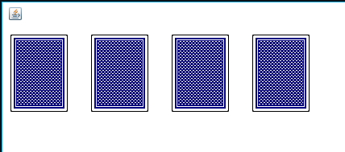

13) Modify the code you wrote for the previous question:  
if the user clicks on a card, flip the card face up  
  
**Here is my Code:**

**Sprite cards[] = new Sprite[] {**

**new Sprite(new ImageIcon("h2.gif").getImage(), 10, 10),**

**new Sprite(new ImageIcon("h2.gif").getImage(), 110, 10),**

**new Sprite(new ImageIcon("h3.gif").getImage(), 210, 10),**

**new Sprite(new ImageIcon("h3.gif").getImage(), 310, 10)**

**};**

**Concentration conObject = new Concentration(cards);**

**public void initializeSprites(){**

**/* sprite initialization code goes here */**

**}**

**public void paintFrame(Graphics g) {**

**conObject.paintComponent(g);**

**conObject.ifMouseIsClickedOnCardThenFlipCardFaceUp();**

**}**

**Here is my screenshot:**

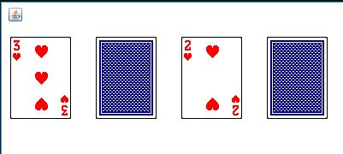

14) Modify the code you wrote for the previous question:  
Paint, on the screen, the number of cards that are flipped up.

**Here is my Code:**

**Sprite cards[] = new Sprite[] {**

**new Sprite(new ImageIcon("h2.gif").getImage(), 10, 10),**

**new Sprite(new ImageIcon("h2.gif").getImage(), 110, 10),**

**new Sprite(new ImageIcon("h3.gif").getImage(), 210, 10),**

**new Sprite(new ImageIcon("h3.gif").getImage(), 310, 10)**

**};**

**Concentration conObject = new Concentration(cards);**

**int numberOfCardsFU = 0;**

**public void initializeSprites(){**

**/* sprite initialization code goes here */**

**}**

**public void paintFrame(Graphics g) {**

**g.setFont(new Font("Consolas", Font.BOLD, 24));**

**conObject.paintComponent(g);**

**conObject.ifMouseIsClickedOnCardThenFlipCardFaceUp();**

**numberOfCardsFU = conObject.numberOfFaceUpCards();**

**g.drawString("Cards flipped up: " + numberOfCardsFU, 70, 300);**

**}**

**Here is my Screenshot:**

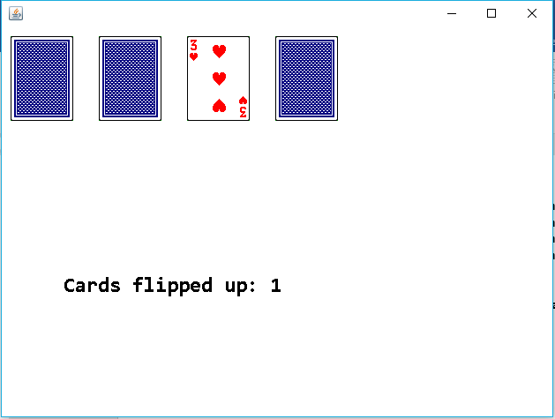

15) Modify the code you wrote for the previous question.  
2 seconds after the message appears, delete the message.

**Here is my Code:**

**Sprite cards[] = new Sprite[] {**

**new Sprite(new ImageIcon("h2.gif").getImage(), 10, 10),**

**new Sprite(new ImageIcon("h2.gif").getImage(), 110, 10),**

**new Sprite(new ImageIcon("h3.gif").getImage(), 210, 10),**

**new Sprite(new ImageIcon("h3.gif").getImage(), 310, 10)**

**};**

**Concentration conObject = new Concentration(cards);**

**int numberOfCardsFU = 0;**

**int timeDelay = 30;**

**String message = "";**

public void initializeSprites(){

/* sprite initialization code goes here */

}

public void paintFrame(Graphics g) {

**g.setFont(new Font("Consolas", Font.BOLD, 24));**

**conObject.paintComponent(g);**

**if (timeDelay > 0) {**

**if(isMouseClicked()) {**

**timeDelay = 30;**

**conObject.ifMouseIsClickedOnCardThenFlipCardFaceUp();**

**numberOfCardsFU = conObject.numberOfFaceUpCards();**

**message = "Cards Flipped Up: " + numberOfCardsFU;**

**}**

**timeDelay--;**

**g.drawString(message, 70, 300);**

**return;**

**}**

**message = "";**

**timeDelay = 30;**

}

**Here is my screenshot:**

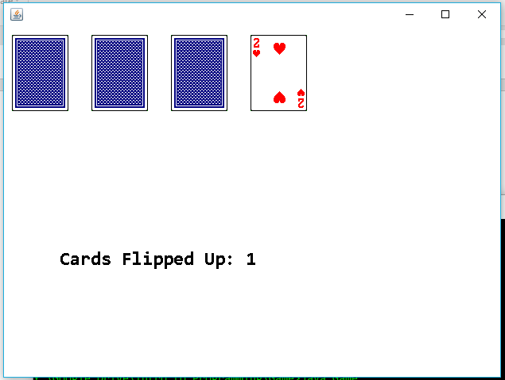

**Two seconds later:**

